MIAI 146th ANNUAL MEETING & CONVENTION
November 8, 9 and 10, 2026

Sunday, November 8, 2026
Registration Meadows Entrance 2:00 - 7:00
Audit Committee Grandquist Room 1:30 – 2:00
Board of Directors Meeting Grandquist Room 2:00 – 4:00
Quarterbacker Club AJ Steakhouse 4:00 – 5:30
Exhibit Booths Bishop A/B/C 6:30 – 8:30
Silent Auction Item Bidding Bishop A/B/C 6:30 – 8:30
President’s Reception Bishop A/B/C 6:30 – 8:30

Monday, November 9, 2026
Hot Buffet Breakfast Bishop A/B/C 7:00 - 8:15
Registration Meadows Entrance 7:00 -11:00
Exhibit Booths Bishop A/B/C 7:00 - 4:30
Silent Auction Item Bidding Bishop A/B/C 7:00 – 4:00
Call to Order Bishop A/B/C 8:30 Invocation, Presentation of Flags, National Anthem
Keynote Speaker – Chad Greenway Bishop A/B/C 8:45 – 9:45

Refreshment Break Skinner A/B 10:00 - 10:30

MID Session – Chris Feldt Bishop A/B/C 10:30 - 11:30
Building Construction

Breakout Session for Managers Skinner A/B 10:30 –11:30
Julie Pearce – Emerging Technologies

Lunch Meadows Commons Pre-Function 11:30 –12:45

MID Session – Chris Feldt Bishop A/B/C 1:00 – 2:00
Drones in the Mutual

Breakout Session for Managers Skinner A/V 1:00 – 2:00
Mike St. Clair – State of Iowa

Refreshment Break Bishop A/B/C 2:00 - 2:30

MID Session – Steve Pace Bishop A/B/C 2:30 – 3:30
D&O/E&O

Prime/Public Service Award Recipient Bishop A/B/C 3:30 – 4:00

Silent Auction Item Bidding Closes Bishop A/B/C 4:00

Exhibitor Prize Drawings Bishop A/B/C 4:00 – 4:30

Buses Pickup up to shuttle to Iowa
Historical Society Building Meadows Entrance 4:30 – 5:30
Buffet Dinner and Cash Bar Historial Society Building 5:00 – 10:00

Tuesday, November 10, 2026

Hot Breakfast Buffet Bishop A/B/C 7:00 - 8:00
Exhibit Booths (Optional) Bishop A/B/C 7:00 – 11:15
Call to Order Bishop A/B/C 8:00

Tuesday Keynote – Neil Aldredge Bishop A/B/C 8:00 – 9:00

Refreshment Break Bishop A/B/C 9:00 - 9:15

MID – Phillip Arnzen, Public Policy Bishop A/B/C 9:15 - 10:15

Refreshment Break Bishop A/B/C 10:15 - 10:30

President’s Report Bishop A/B/C 10:30 - 11:00
Outgoing Officers/Directors recognized
Secretary’s Report
Annual Meeting
Guaranty Fund Meeting

President’s Award Bishop A/B/C 11:00 - 11:15
Introduction New President
Prizes

Board Meeting Grandquist Room 11:30 a.m.

______________________________________________________

Suggested Attire for the Convention is business casual.

Registered spouses are welcome at all sessions and meals.

About the Speakers
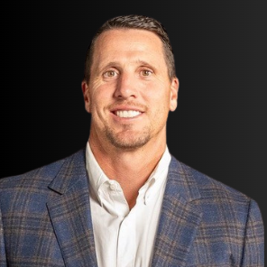
Chad Greenway’s journey embodies the values of hard work, resilience, and community spirit. Born and raised on a hog, cattle, and crop farm in Mt. Vernon, SD, Chad learned the importance of dedication and perseverance from an early age. Growing up in a tight-knit rural community, he quickly assumed leadership roles both on the family farm and within the local community.

His path led him to the University of Iowa on a football scholarship, where he shone brightly as a standout player. Named 3-time All Big Ten and a 2-time All American, Chad’s leadership was recognized by his peers, earning him a place on the leadership council throughout his college years. Graduating with a degree in Communication Studies in 2005, Chad’s journey was only just beginning.

Selected #17 overall in the 2006 NFL Draft by the Minnesota Vikings, Chad embarked on an illustrious 11-season career, all with the Vikings. As a key player, he earned numerous accolades, including All-Pro and Pro-Bowl selections, and served as a respected team captain. Off the field, Chad’s commitment to making a difference was evident, as he was honored multiple times for his charitable contributions, including winning the NFLPA’s prestigious Byron “Whizzer” White award.

Since retiring from the NFL in 2017, Chad has continued his impactful work in the Twin Cities community. As President of his family’s Lead the Foundation, established in 2010, he remains dedicated to supporting families and children across the upper Midwest. Additionally, Chad has embraced new ventures as a Partner with Gray Duck Spirits and Bankshot Solutions, furthering his commitment to innovation and community engagement.

At home in Wayzata, MN, Chad finds joy in family life with his wife Jennifer and four daughters. Actively involved in coaching, training, and guiding his girls, Chad exemplifies the values of leadership and service both on and off the field.
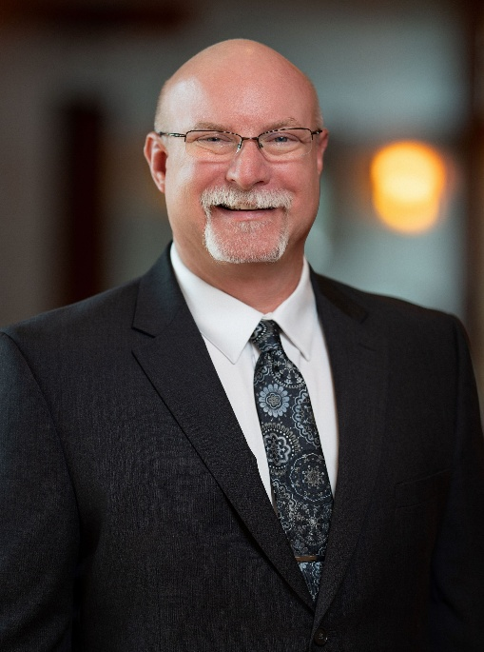
Chris is the Chief Executive Officer at Heartland Mutual Insurance Company in Belleville, Illinois where he began his career in 2007 as an Inspector/Adjustor. He was promoted to Manager in 2012. His title changed to Chief Executive Officer in January 2023. He is a retired member of the Northwest Fire Protection District where he served for 28 years, 18 of those years he served as a Captain. Before coming to Heartland, Chris worked in the construction industry conducting inspections and building homes; those skills and experience have been useful to him in his current position.
Chris has been active over the years by sharing his knowledge of Insurance & the building industry with NAMIC, IAMIC and other State Associations by conducting presentations. Chris is currently the Chairman of the Agriculture Advisory Committee at Southwestern Illinois College in Belleville. Chris served as Chairman for his State Association from 2023-2024, while also serving as an At Large Director for his state association from 2016-2018 & between 2020 to 2023.
Chris also served as Chairman of the 2018 National Association Mutual Insurance Companies “NAMIC” Farm Forum and the 2024 NAMIC Farm Mutual Conference Board where Chris served on this board from 2018 to 2024.
Chris received his Professional Farm Mutual Manager (PFMM) designation in 2013 along with the Merit Award in 2014. He also received the IAMIC Volunteer Award in both 2015 & 2017 and received his Farm Mutual Directors Certification (FMDC) designation in 2021. He also received the NAMIC Professional Farm Mutual Manager of the year award for 2023. In 2025 Chris received the LAUTUM award from the Illinois Association of Mutual Insurance Companies “IAMIC”.
He earned an Associate's degree in Fire Science from Southwestern Illinois College and a Bachelor's degree in Business Administration/Management from Lindenwood University. He and his wife, Amy, have a son, Kyle and a daughter, Kaitlynn plus two black labs named Everest and Rainier. When Chris is not at work, he, and his family love to go camping and working on home projects.

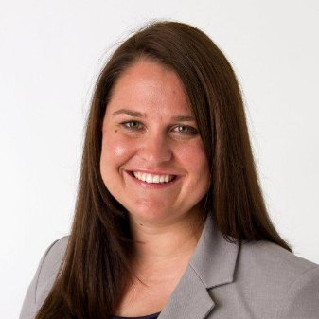
Julie Pearce is serving as Acting Deputy Insurance Commissioner for Market Regulation. She works alongside Commissioner Ommen in maintaining fair, completive, and well-regulated insurance market for all Iowans. Her department works on outreach efforts on financial literacy, insurance education and investor protection in our schools, and more broadly, to all Iowans. Pearce brings over 19 years of extensive insurance and financial services experience spanning Life, Annuity, and Property & Casualty lines to the role.
Prior to her appointment as Acting Deputy, Pearce served as a Holding Company Specialist at the Insurance Division since 2024. In this capacity, she has overseen strategy and risk management for a complex Internationally Active Insurance Group (IAIG), with key focus areas including Cross-Border Reinsurance, Group Capital Calculation, Corporate Governance, AI systems evaluation, financial performance, and ORSA reporting. She has also led efforts on the Property and Casualty Personal Lines Task Force, coordinating industry-leading recommendations to navigate market dynamics surrounding social inflation, natural disasters, and elevated claims activity.
Prior to joining the Department, Pearce worked in the financial services industry for over 15 years, including her latest role at Wellabe (formerly American Enterprise Group), serving as Vice President, Chief Business Development & Transformation Officer. During her tenure, she managed a team’s overseeing agency sales, innovation, and strategic corporate development. Her previous career highlights also include management roles at Farmers Mutual Hail Insurance Company of Iowa and Ernst & Young LLP.
In addition to her professional career, Pearce is an active leader in the broader insurance community. She served as Co-Chair for the 2025 and 2026 Global Insurance Symposiums, presents on emerging technologies like Agentic AI supervision, and acts as a mentor for the Global Insurance Accelerator.
Pearce holds both a Master’s degree in Investment Management and Financial Analysis and a Bachelor of Science in Business Administration with degrees in Accounting and Finance from Creighton University.

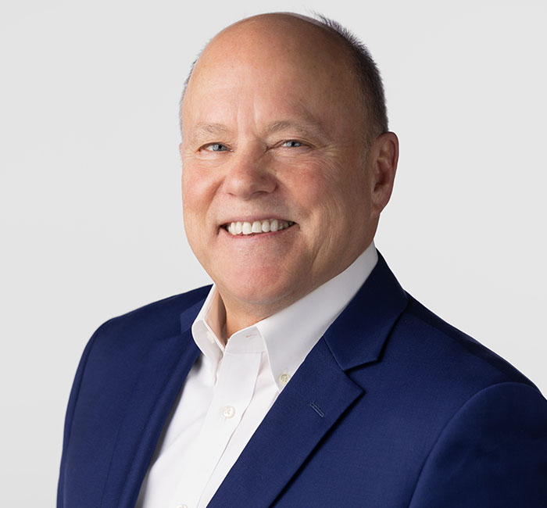
Steven Pace has been an environmental attorney at Shuttleworth & Ingersoll, P.L.C. since 1977. Steve is the chair of the firm’s environmental law and natural resources law practice group. Steve’s work focuses on environmental law, civil litigation, insurance law and energy law. Steve has represented and defended many companies and individuals on litigation, environmental claims, environmental compliance, insurance claims, insurance compliance, energy law and related matters.

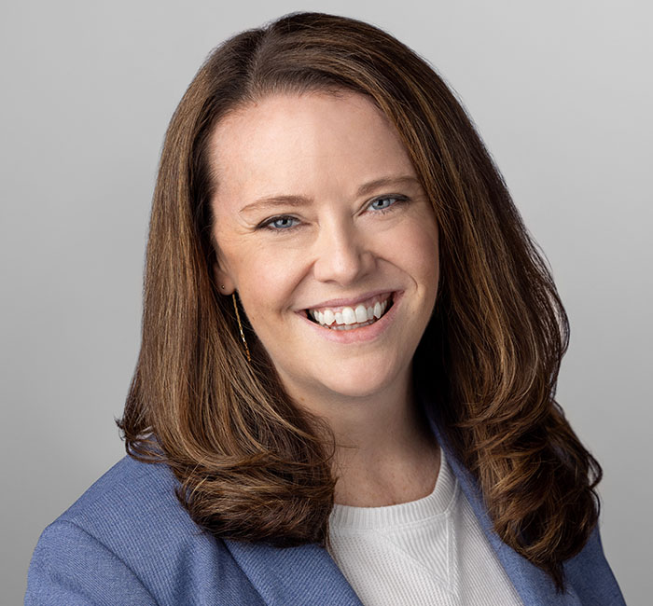
Megan R. Merritt is an attorney and senior vice president at Shuttleworth & Ingersoll, P.L.C. Megan tries cases to judges and juries in state and federal court, protecting the interests of her individual and business clients.
Megan has represented a broad range of individuals and businesses, including small businesses, large corporations, and insurance companies in the areas of personal injury, construction, and contract. Megan has also worked with city governments to craft and enact local ordinances, maintain compliance with state and federal laws, and create employee policies.

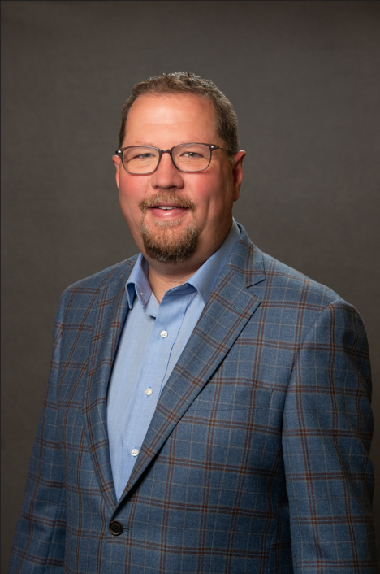
Neil Alldredge serves as president and chief executive officer of the National Association of Mutual Insurance Companies, a property/casualty insurance trade association representing more than 1,300 member companies that write $383 billion in annual premiums.
Alldredge assumed the role of president and CEO in July 2021 after serving in various executive roles at NAMIC. He joined the association in 1999, leading NAMIC’s state legislative, regulatory, and international advocacy efforts for 17 years. In that role Alldredge regularly testified before state legislators around the country and represented NAMIC members at the National Association of the Insurance Commissioners, the National Conference of Insurance Legislators, and the International Association of Insurance Supervisors. He also served on the board of directors of the Advocates for Highway Safety and as board chair of the NCOIL’s Industry Education Council.
In 2017, Alldredge was named senior vice president of corporate affairs, where he led NAMIC’s membership retention and recruitment, events and education, public affairs, compliance, and marketing and technology areas. He currently chairs the board of the NAMIC Insurance Company (NAMICO) and serves on the board of the NAMIC Mutual Insurance Foundation. Alldredge also serves on the board of the Insurance Institute for Highway Safety, and is part of the Global Federation of Insurance Associations (GFIA) General Assembly. Prior to joining NAMIC, Alldredge served as director of Planning and Research for the Indiana State Senate.
Alldredge has a bachelor’s degrees in political science and communications and a master’s degree in rhetoric from Ball State University.
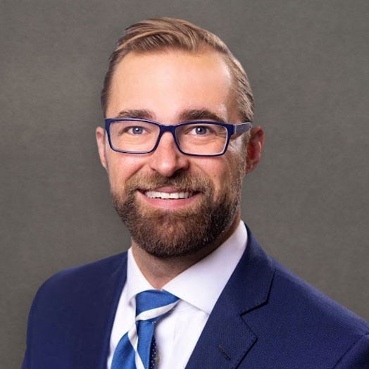
Phillip Arnzen is the regional vice president for the Midwest, advocating for member companies across Colorado, Iowa, Missouri, Nebraska, North Dakota, and South Dakota.

Before NAMIC, he served as director of legislative affairs at the Missouri Chamber of Commerce and Industry after serving as deputy legislative director in the Missouri Governor’s Office. He also worked at the Missouri Department of Economic Development in legislative affairs and in Missouri’s Speaker Pro Tempore office as chief of staff as well as numerous political campaigns for local and statewide races.

He graduated with a bachelor’s degree in financial planning from the University of Missouri.

